East China tour – April 14-25th, 2018

Prof. Sylvestre Bonnet
Leiden Institute of Chemistry, Leiden University, Leiden, The Netherlands
E-mail: bonnet@chem.leidenuniv.nl
Google Scholar profile: https://scholar.google.nl/citations?user=KsMjKMQAAAAJ&hl=nl&oi=ao
ORCID: https://orcid.org/0000-0002-5810-3657

Lecture 1: Triggering blue light activation of anticancer metallodrugs using red light: molecular and supramolecular strategies

Photo-Activated Chemotherapy (PACT), like PhotoDynamic Therapy (PDT), aims at activating anticancer medicines with visible light to circumvent to the tumor site the toxicity of chemotherapy. Usually, PACT agents are activated by photocleavage of a metal-ligand bond. While this type of photochemistry typically requires UV or blue light, which has a lot of energy but does not penetrates very well in biological tissues, it is also possible to trigger it using red photons, which have much less energy but penetrate much better biological tissues. In this presentation, I will show molecular and supramolecular tricks that allow to activate using red light three different blue light-sensitive metal-based compounds: a photo caged PACT inhibitor, a ruthenium-based anticancer compound, and a photoactived CO-releasing molecule (photoCORM).
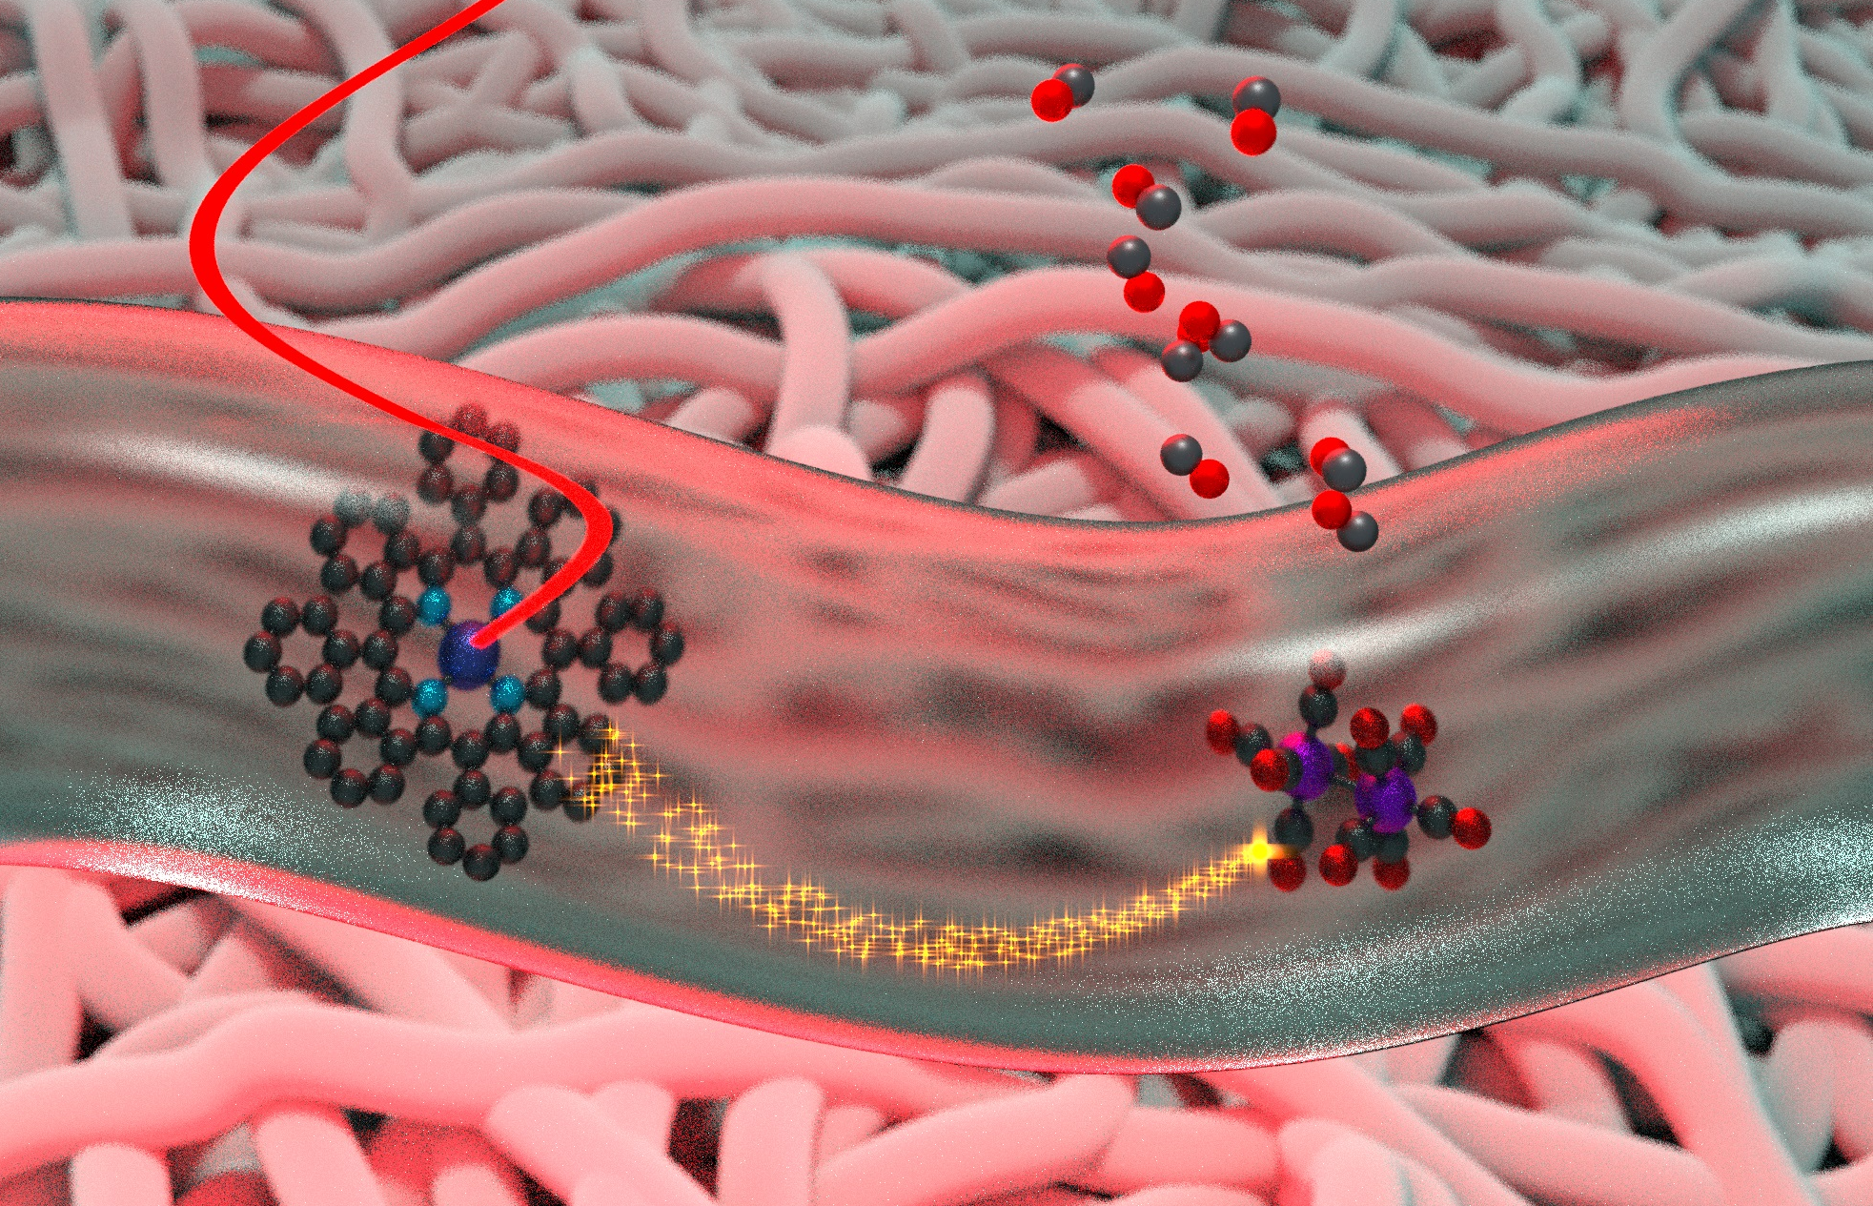
References:
[1] S. H. C. Askes, A. Bahreman, S. Bonnet*, Angew. Chem. Int. Ed. 2014, 53, 1029
[2] L. N. Lameijer, D. Ernst, S. L. Hopkins, M. S. Meijer, S. H. C. Askes, S. E. Le Dévédec, S. Bonnet*, Angew. Chem. Int. Ed. 2017, 56,11549
[3] S. H. C. Askes, U. R. Gandra, R. Wyrwa, S. Bonnet*, A. Schiller*, J. Am. Chem. Soc. 2017, 139, 15292

Lecture 2: Light activation of anticancer metallodrugs using blue, green, or red light: towards treatment of hypoxic tumors

Photo-Activated Chemotherapy (PACT), like PhotoDynamic Therapy (PDT), aims at activating anticancer medicines with visible light to circumvent to the tumour site the toxicity of chemotherapy. Usually PACT agents are activated by photocleavage of a metal-ligand bond. While this type of photochemistry typically requires blue light, it is possible to obtain green or red light activation by playing photochemical tricks. In this presentation, several PACT compounds based on ruthenium will be presented that can be activated with blue, green, or red light. In some of them, it is the metal-based fragment that is responsible for the light-induced cytotoxicity, while in other cases it is the ligand that provokes cell death. As metal-ligand bond cleavage reactions do not require the presence of oxygen, PACT may allow for treating hypoxic tumours. We will close the lecture by showing our first results on PACT compounds tested in hypoxic conditions, ie, in cancer cells grown in presence of low dioxygen concentrations.
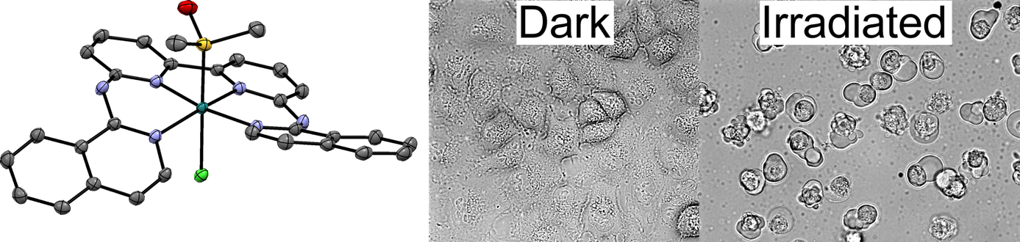
References:
[1] L. N. Lameijer, S. L. Hopkins, T. G. Brevé, S. H. C. Askes, S. Bonnet*, Chem. Eur. J. 2016, 22, 18484
[2] J.-A. Cuello-Garibo, M. S. Meijer, S. Bonnet,* Chem. Commun, 2017, 53, 6768
[3] V. H. S. van Rixel, B. Siewert, S. Hopkins, S. H. C. Askes, A. Busemann, M. A. Siegler, S. Bonnet*, Chem. Sci. 2016, 7, 4922
[4] L. N. Lameijer, D. Ernst, S. L. Hopkins, M. S. Meijer, S. H. C. Askes, S. E. Le Dévédec, S. Bonnet*, Angew. Chem. Int. Ed. 2017, 56,11549

Lecture 3: Photocatalysis at the surface of liposomes

The past decades have led to a great increase in the availability of water oxidation catalysts with high TOFs and TONs.[1] Under photocatalytic water oxidation conditions, these novel catalysts are fast and stable enough to not be the limiting factor in the photocatalytic cycle anymore. Instead, the photosensitizer degrades during the photoreaction, thus limiting the overall efficiency and TON of the system. Supramolecular systems such as liposomes influence greatly the stability and rates of (photo)catalytic processes.[2] In this work, both a water oxidation catalyst and a photosensitizer were anchored to the surface of a lipid bilayer by means of a long alkyl tail. The stability of the photosensitizer is increased by anchoring, which leads to higher TONs for the photocatalytic oxidation of water, compared to homogeneous conditions. Furthermore, the efficiency of the system was shown to depend very much on the local concentration of photosensitizer and catalyst, indicating that fast hole transfer from the photosensitizer to the catalyst is essential for the stability of the system.[3][4]
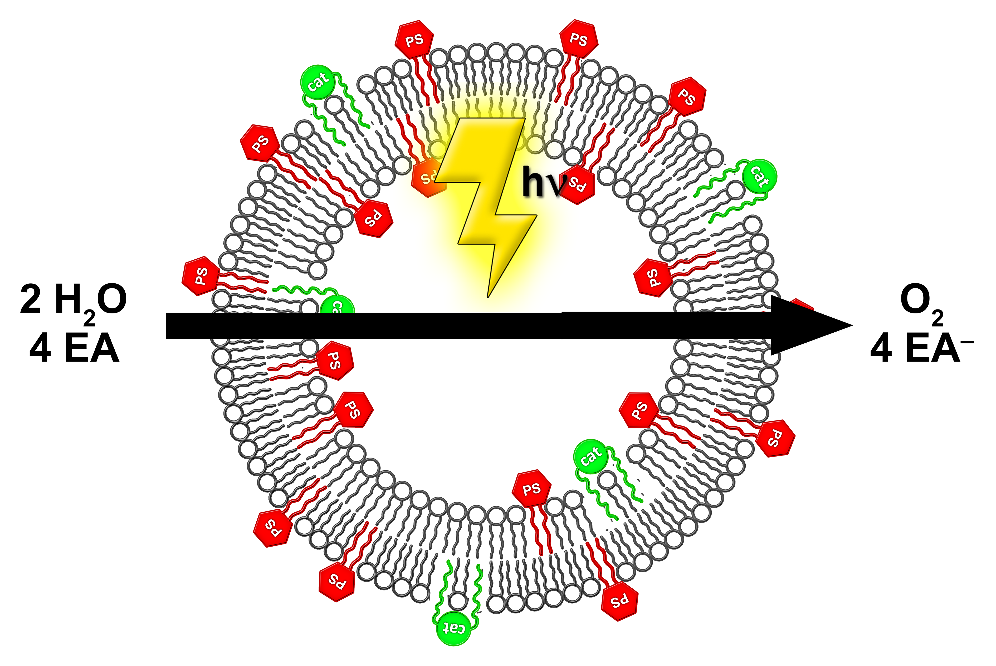
References:
- B. Limburg, E. Bouwman, S. Bonnet, Coord. Chem. Rev. 2012, 256, 1451
- B. Limburg, E. Bouwman, S. Bonnet, Chem. Eur. J. 2014, 20, 8965
- B. Limburg, E. Bouwman, S. Bonnet ACS Catal. 2016, 6, 5273
- B. Limburg, E. Bouwman, S. Bonnet, ACS Catal. 2016, 6, 5968

Short CV

In 2005 Sylvestre Bonnet obtained a PhD on light-activated molecular machines with Nobel Laureate Jean-Pierre Sauvage at the University of Strasbourg, France. He then moved to The Netherlands as a postdoctoral fellow, first in the group of Gerard van Koten (Utrecht University), then with Jan Reedijk (Leiden University). After obtaining a Veni grant from The Netherlands Organization for Scientific Research (NWO) in 2008 he completed a Tenure Track position at Leiden University (2009-2014) and obtained a Tenure as Associated Professor in 2015. He obtained several grants including a NWO-Vidi grant in 2012 and an ERC Starting Grant in 2013; he is also Board Member of the Young Academy of Europe. His expertise lies at the crossing point between bioinorganic chemistry, photochemistry, and liposomes. His current research interests are light-activated anticancer metallodrugs, photocatalysis, and upconversion strategies.

